v

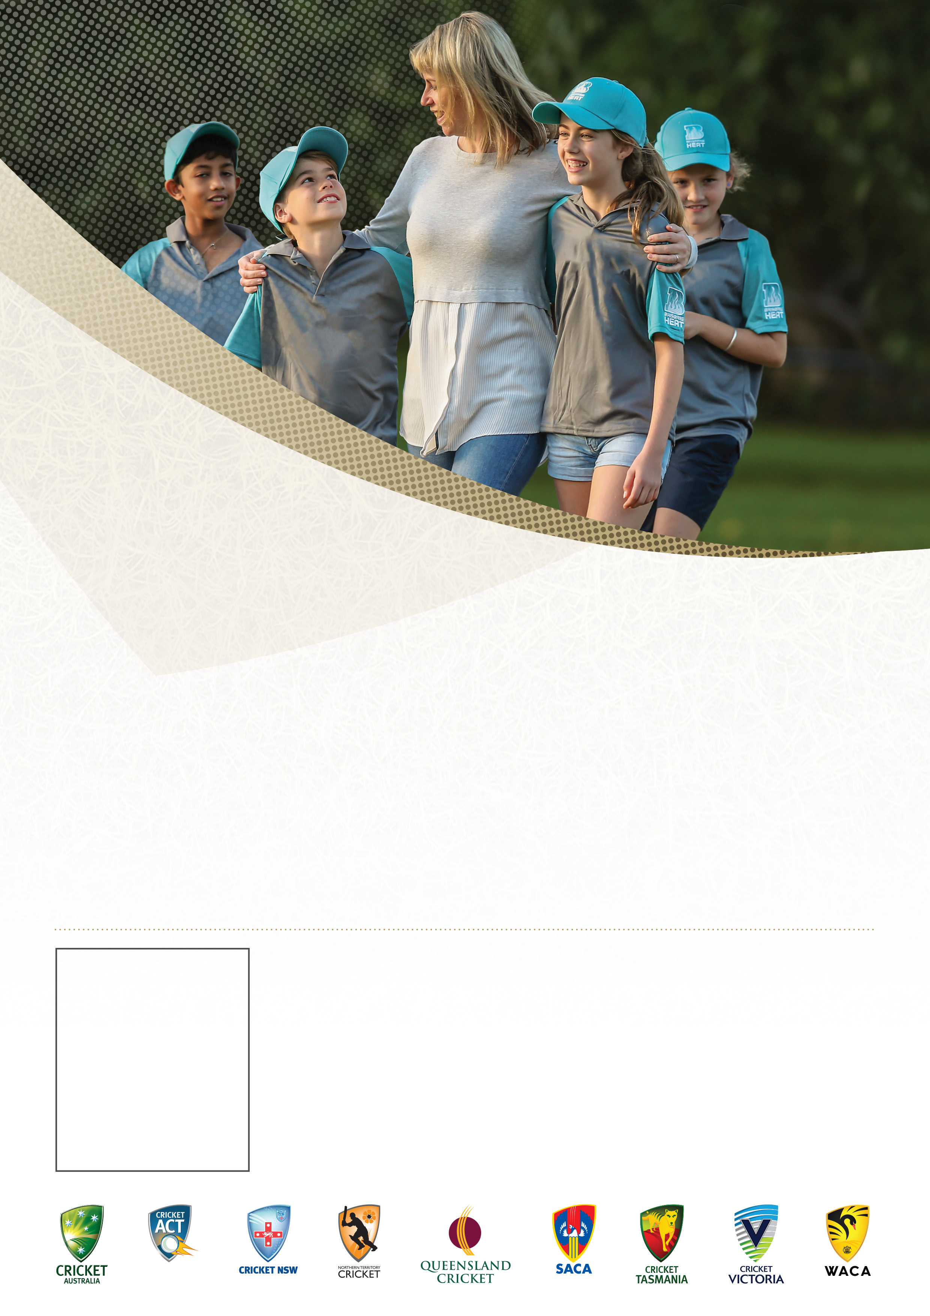

**Andrew Williams**

**0439906680**